

Bachelor of Computer Applications
Semester – V
Deep Learning

Project – 08
Title: Gradient Descent Implementation

Submitted By:
Poojashree H
Reg. No.: 2411021240046
Date: 03/10/2026

Submitted To:

Faculty Name: Nagasri p

Department of Computer Application Alliance University
Chandapura - Anekal Main Road, Anekal Bengaluru – 562106

OCTOBER 2026

Github link : https://github.com/Pooja27-web/Deep-Learning

Objective

The objective of this project is to implement the Gradient Descent algorithm from scratch and understand how a model's parameters are iteratively updated to minimize prediction error. A simple linear regression problem is used to clearly observe how the weight and bias evolve over training iterations and how the loss decreases as a result.
Dataset Description

A synthetic dataset of 50 samples was generated following the linear relationship:
y = 4 + 3x + noise
Here, the "true" parameters the model is expected to learn are a weight close to 3 and a bias close to 4, with small random noise added to simulate real-world data variation.

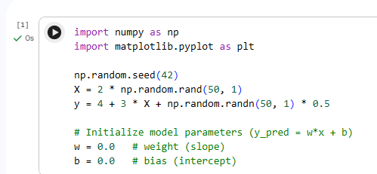

Methodology

Parameter Initialization (Task 1)

The model is a simple linear function: y_pred = w·x + b. Both parameters were initialized to zero, meaning the model starts with no knowledge of the relationship between input and output.

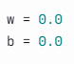

Gradient Descent Algorithm (Task 2)

For each iteration, the algorithm:
- Computes predictions using current parameters (forward pass).
- Calculates the loss using Mean Squared Error (MSE).
- Computes the gradient of the loss with respect to w and b.
- Updates the parameters by moving them against the gradient, scaled by a learning rate.

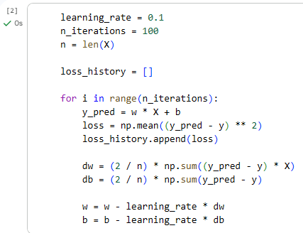

Loss Tracking and Visualization (Task 3)

The loss value was recorded at every iteration to observe the training trend, and plotted using Matplotlib to visualize convergence.

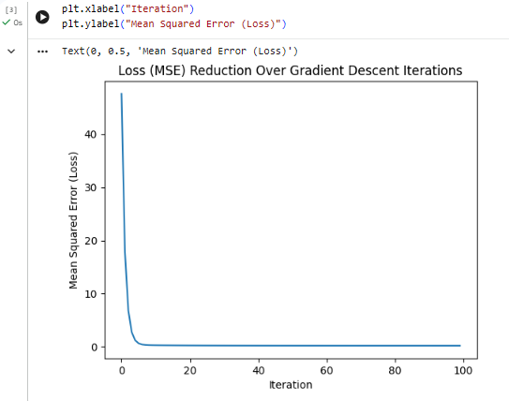

The final learned parameters (w ≈ 2.97, b ≈ 4.03) closely match the true underlying relationship (w = 3, b = 4), confirming that the model successfully learned from the data.

Loss curve: The loss drops sharply from ~47.6 to below 1 within the first 10–15 iterations, then gradually flattens and stabilizes around 0.206 by iteration 100.

Fitted line: Plotting the final regression line (y = 2.97x + 4.03) against the original data points showed a close visual fit, confirming the correctness of the learned parameters.

Discussion

- Convergence pattern: Most of the error reduction occurs in the first ~15 iterations, after which improvements become marginal. This steep-then-flat curve is typical of Gradient Descent, since large initial gradients produce large corrections, while smaller gradients near the optimum produce smaller updates.

- Effect of learning rate: A learning rate of 0.1 allowed fast, stable convergence. A larger learning rate risks overshooting the minimum and causing instability, while a smaller one would converge correctly but much more slowly.

- Residual loss: The final loss does not reach zero because the dataset includes random noise, meaning a small irreducible error is expected even with perfectly optimized parameters.

Conclusion

This project successfully implemented Gradient Descent from scratch to train a simple linear model. By iteratively computing gradients and updating the weight and bias, the model's loss decreased from an initial value of 47.58 to approximately 0.21 over 100 iterations, and the learned parameters closely matched the true data-generating relationship. This demonstrates the fundamental mechanism computing gradients and adjusting parameters against them that underlies training in nearly all machine learning and deep learning models.

